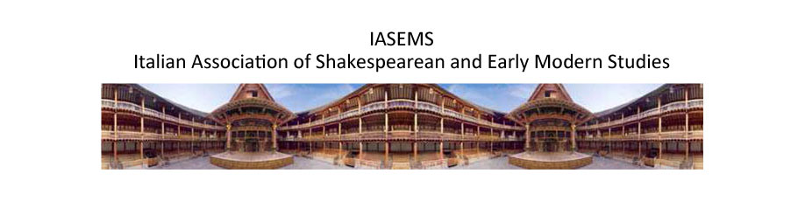
Call for Papers - The 2017 IASEMS Graduate Conference

The fine art of lying:
disguise, dissimulation and counterfeiting
in early modern culture

Florence, 7 April 2017

The 2017 IASEMS Graduate Conference at The British Institute in Florence is a one-day interdisciplinary forum open to PhD students and researchers who have obtained their doctorates within the past 5 years.

Dissimulation is but a faint kind of policy, or wisdom; for it asketh a strong wit, and a strong heart, to know when to tell truth, and to do it. Therefore it is the weaker sort of politics, that are the great dissemblers! (Francis Bacon, “Of Dissimulation”)

Throughout history the question of what a lie is and whether it is wrong to lie has been the subject of a lively debate among Western philosophers and theologians. In antiquity, lying has been often stigmatized and condemned on religious, moral and legal bases: it is a sin, a transgression, a criminal offense and therefore intrinsically wrong and morally reprehensible. Contrary to this absolutist position, held by philosophers such as Augustine and Kant, the utilitarian perspective, put forth by Bentham and Mill in the nineteenth century and expanded by J.L. Austin in the twentieth century, proposes that the concept of lying and its moral implications are context dependent and defined by social conventions.

The aim of the conference is to explore lying and related concepts such as falsehood, deceit, disguise, dissimulation, counterfeiting, the role they have and the values they entail in early modern culture. Discussions on lying also imply a range of other issues and questions concerning truth, its attainability and the meaning of its attainment; and notions of trust, faith, belief. During the conference we want to reflect on these topics and also explore creative ways of eluding the prohibition of lying through linguistic and rhetorical strategies such as, for instance, equivocation and amphibology.

We welcome contributions addressing (but not necessarily restricted to) the following topics:

- The confession and condemnation of lies
- Justifications for lying
- Lying to enemies, liars
- Lies protecting family, friends and the public good
- White lies
- Dissimulation of religious belief and unbelief
- Counterfeiting and propaganda
- The use of dissimulation in politics
- Truth and falsehood in early modern news
- Metatheatre and embedded plays
- Disguise on early modern stage and in prose fiction
- Literary dissimulation and its linguistic implication

Candidates are invited to send a description of their proposed contribution according to the following guidelines:

Please provide name, institution, contact info, title and a short abstract of the proposed contribution (300 words for a 20-minute paper), including a short bibliography.
Abstracts are to be submitted by 31 October 2016 by email to ilaria.natali@unifi.it
All proposals will be blind-vetted. The list of selected papers will be available by 30 November 2016.
Each contribution is to last no longer than 20 minutes and is to be presented in English; candidates whose first language is not English are kindly asked to have their paper revised by a native speaker.
Participants will be asked to present a final draft of the paper two weeks before the Conference.

Selected speakers who are IASEMS members can apply for a small grant. Please contact Alessandra Petrina at alessandra.petrina@unipd.it and Laura Tosi at tosilaur@unive.it

Information on how to become IASEMS members is available here

http://www.maldura.unipd.it/iasems/iasems_registration.html

